A mechanic says, "During the removal of the L/H engine, the engine mount *(was found)* to have a large crack."

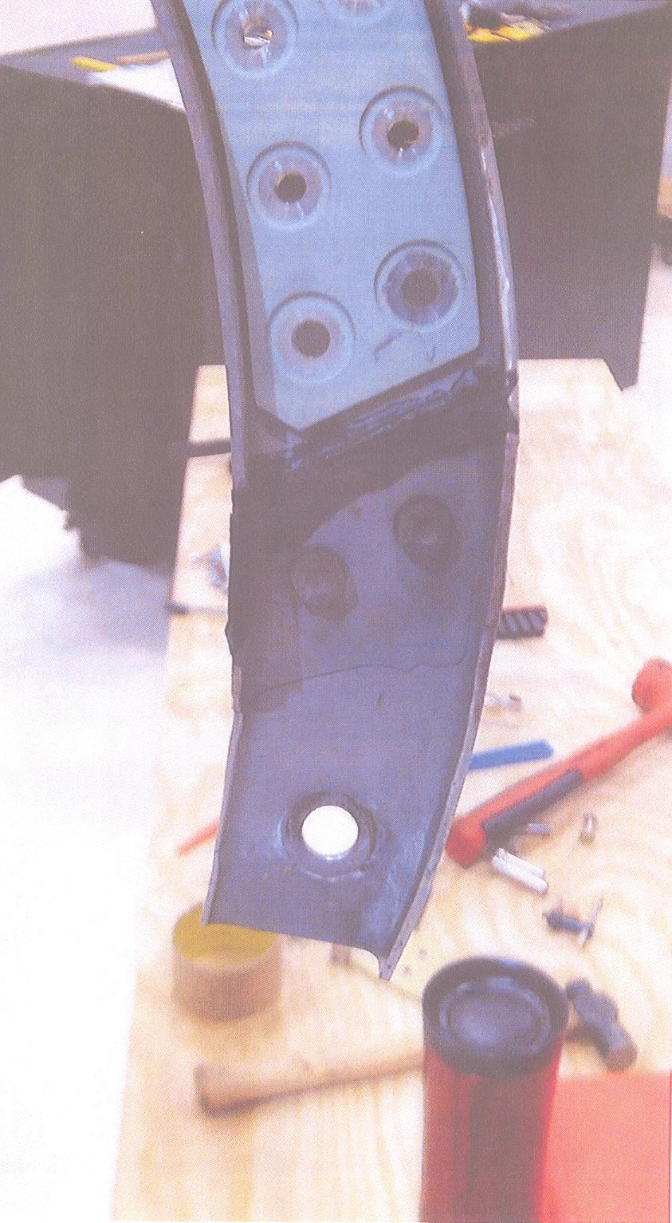

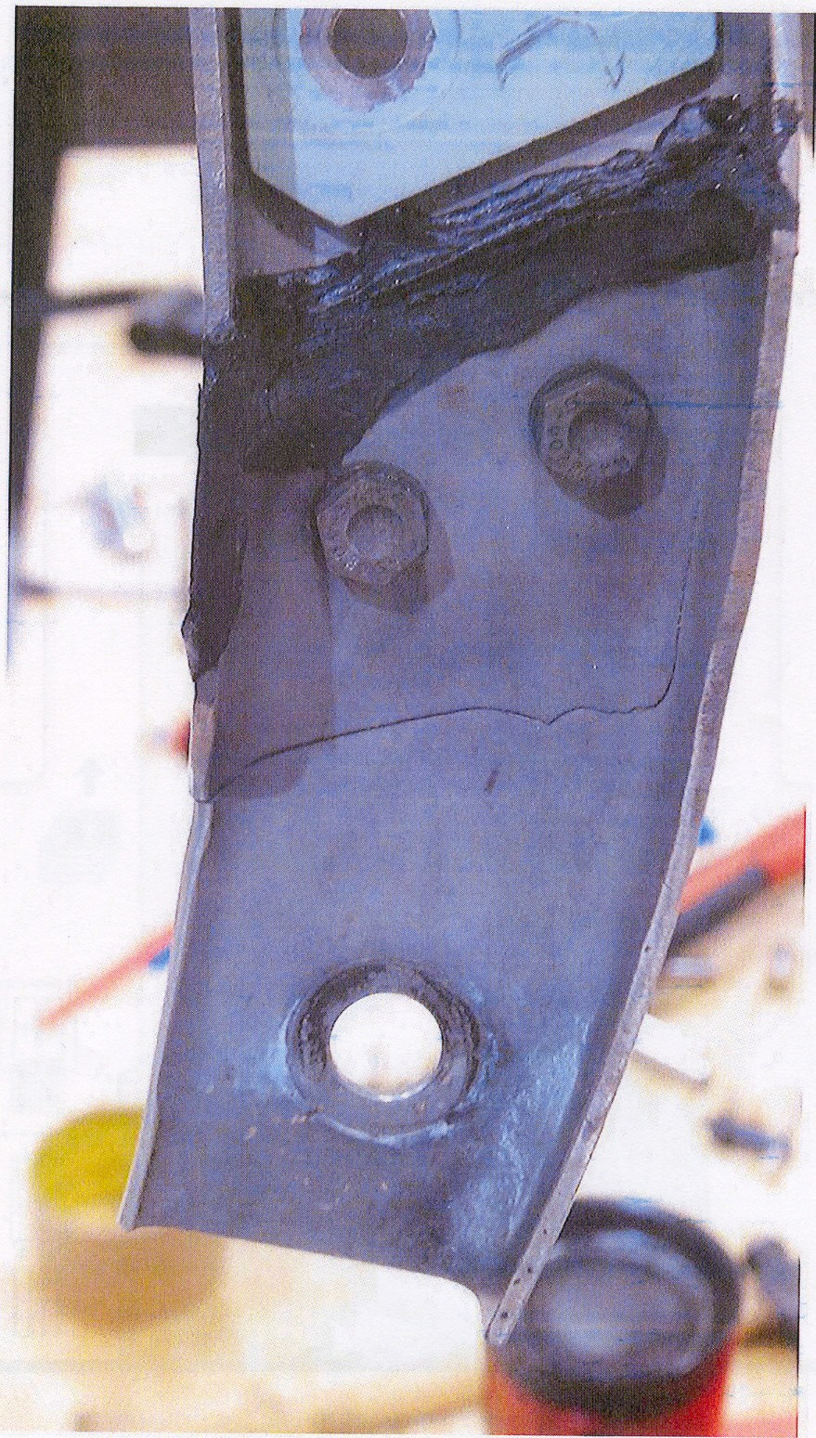

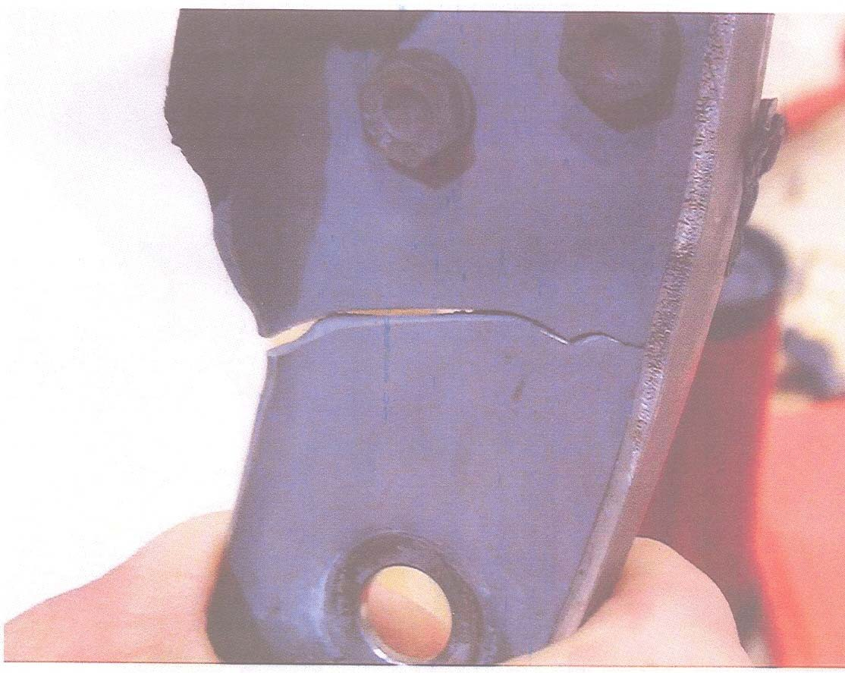

(The first two photos have been artistically "forced" to fit the page. Engine mount P/N: 45A34361005. There are at least eight such records in the SDRS database.)

Part Total Time: (unknown)